# Results

Two sets of optimal Thresholds (Values 1 and 2) for the algorithms were chosen. One through matching based on Weighted Similarity and one through matching based on the number of clusters.

|  |  |
| --- | --- |
| Algorithm | Threshold |
| CDMLz4 | .76 |
| CDMSequitur | .66 |
| Lz4 | .3 |
| Values 1 | |

**Optimal Threshold # 1 by W. Sim comparison Optimal Threshold # 2 by # Clu comparison**

|  |  |
| --- | --- |
| Algorithm | Threshold |
| CDMLz4 | .64 |
| CDMSequitur | .34 |
| Lz4 | .18 |
| Values 2 | |

The 3 algorithms were run on 6 data sets from the 16S collection of Environmental data sets collected in the field. The algorithms were then compared to the current leading clustering algorithms in number of clusters, weighted similarity, and runtime. Tables 1 and 2 show the results with both thresholds.

In terms of runtime, CDMLz4 very closely matched the runtime of the current leading algorithm, MC-MinH. All 3 of my algorithms correlated in weighted similarity with the leading algorithms but did not come close in number of clusters using threshold #1. However with Thershold #2, they matched in number of clusters and greatly exceeded the weighted similarity of the competitors.

Tables 3 and 4 show the species diversity comparison of my three algorithms with MC-MinH the widely used clustering algorithm. Threshold #1 performs poorly in diversity while threshold #2 more closely matches the diversities found in the clusters of MC-MinH. Figures 1 -6 are graphs comparing the 3 diversity indexes among the two thresholds.

**Clustering Results on 16S Environmental sets using Threshold #1**

|  |  |  |  |  |  |  |  |  |
| --- | --- | --- | --- | --- | --- | --- | --- | --- |
| Algorithm | Metric | | 53R | 55R | 112R | 115R | 137 | 138 |
| CDMLz4 | # Clu | | 320 | 288 | 507 | 324 | 306 | 308 |
| W.Sim | | 94.30 | 93.35 | 92.01 | 94.30 | 93.81 | 93.91 |
| Time(s) | | 6.9 | 5.1 | 5.5 | 5.3 | 9.2 | 6.4 |
| CDMSequitur | # Clu | 346 | | 292 | 528 | 322 | 306 | 319 |
| W.Sim | 93.93 | | 93.07 | 92.41 | 92.42 | 93.79 | 93.99 |
| Time(s) | 59.4 | | 44.9 | 59.5 | 333.0 | 71.8 | 58.3 |
| Lz4 | # Clu | 517 | | 448 | 775 | 509 | 456 | 465 |
| W.Sim | 96.63 | | 95.39 | 96.00 | 95.73 | 96.08 | 95.91 |
| Time(s) | 21.5 | | 14.3 | 20.8 | 168.9 | 24.0 | 19.2 |
| MC-MinH | # Clu | 1165 | | 1077 | 1634 | 1156 | 1020 | 1042 |
| W.Sim | 96.90 | | 92.45 | 91.18 | 93.33 | 95.86 | 93.10 |
| Time(s) | 2.5 | | 2.1 | 3.3 | 3.0 | 2.7 | 2.5 |
| MC-LSH | #Clu | 1172 | | 1199 | 1795 | 1205 | 1041 | 1072 |
| W.Sim | 96.90 | | 93.12 | 91.33 | 93.50 | 95.86 | 93.10 |
| Time(s) | 161.0 | | 183.0 | 317.0 | 188.0 | 172.0 | 175.0 |
| UCLUST | #Clu | 1062 | | 992 | 1561 | 1071 | 900 | 923 |
| W.Sim | 96.67 | | 91.67 | 91.02 | 93.33 | 93.50 | 92.82 |
| Time(s) | 2.0 | | 2.0 | 2.0 | 2.0 | 2.0 | 2.0 |
| CD-HIT | #Clu | 824 | | 716 | 1196 | 820 | 712 | 725 |
| W.Sim | 92.56 | | 90.80 | 90.61 | 93.33 | 91.82 | 90.16 |
| Time(s) | 3.6 | | 3.1 | 3.9 | 3.8 | 3.2 | 3.1 |
| ESPRIT | #Clu | 940 | | 859 | 1361 | 970 | 818 | 832 |
| W.Sim | 93.12 | | 91.35 | 90.88 | 93.33 | 91.82 | 90.16 |
| Time(s) | 283.0 | | 266.0 | 537.0 | 348.0 | 280.0 | 296.0 |
| DOTUR | #Clu | 1241 | | 1258 | 1854 | 1279 | 1096 | 1121 |
| W.Sim | 96.95 | | 94.06 | 91.33 | 93.50 | 95.86 | 93.10 |
| Time(s) | 5129.0 | | 3511.0 | 5567.0 | 9237.0 | 6563.0 | 5618.0 |
| Mothur | #Clu | 1238 | | 1256 | 1853 | 1278 | 1094 | 1119 |
| W.Sim | 96.95 | | 94.06 | 91.33 | 93.50 | 95.86 | 93.10 |
| Time(s) | 10130.0 | | 5940.0 | 12303.0 | 13501.0 | 12861.0 | 12310.0 |

Table 1

**Clustering Results on 16S Environmental sets using Threshold #2**

|  |  |  |  |  |  |  |  |  |
| --- | --- | --- | --- | --- | --- | --- | --- | --- |
| Algorithm | Metric | | 53R | 55R | 112R | 115R | 137 | 138 |
| CDMLz4 | # Clu | | 1009 | 868 | 1419 | 1056 | 849 | 858 |
| W.Sim | | 99.00 | 98.69 | 98.72 | 99.03 | 99.21 | 98.90 |
| Time(s) | | 34 | 24.2 | 23.9 | 24.1 | 34.7 | 27.8 |
| CDMSequitur | # Clu | 827 | | 745 | 1236 | 870 | 803 | 748 |
| W.Sim | 98.27 | | 98.14 | 97.94 | 97.94 | 98.74 | 98.49 |
| Time(s) | 187.7 | | 154.6 | 201.9 | 1032.5 | 244.3 | 186.7 |
| Lz4 | # Clu | 922 | | 777 | 1302 | 921 | 754 | 789 |
| W.Sim | 98.64 | | 98.26 | 98.50 | 98.52 | 98.66 | 98.66 |
| Time(s) | 43.7 | | 31.9 | 43.6 | 384.4 | 47.4 | 37.6 |
| MC-MinH | # Clu | 1165 | | 1077 | 1634 | 1156 | 1020 | 1042 |
| W.Sim | 96.90 | | 92.45 | 91.18 | 93.33 | 95.86 | 93.10 |
| Time(s) | 2.5 | | 2.1 | 3.3 | 3.0 | 2.7 | 2.5 |
| MC-LSH | #Clu | 1172 | | 1199 | 1795 | 1205 | 1041 | 1072 |
| W.Sim | 96.90 | | 93.12 | 91.33 | 93.50 | 95.86 | 93.10 |
| Time(s) | 161.0 | | 183.0 | 317.0 | 188.0 | 172.0 | 175.0 |
| UCLUST | #Clu | 1062 | | 992 | 1561 | 1071 | 900 | 923 |
| W.Sim | 96.67 | | 91.67 | 91.02 | 93.33 | 93.50 | 92.82 |
| Time(s) | 2.0 | | 2.0 | 2.0 | 2.0 | 2.0 | 2.0 |
| CD-HIT | #Clu | 824 | | 716 | 1196 | 820 | 712 | 725 |
| W.Sim | 92.56 | | 90.80 | 90.61 | 93.33 | 91.82 | 90.16 |
| Time(s) | 3.6 | | 3.1 | 3.9 | 3.8 | 3.2 | 3.1 |
| ESPRIT | #Clu | 940 | | 859 | 1361 | 970 | 818 | 832 |
| W.Sim | 93.12 | | 91.35 | 90.88 | 93.33 | 91.82 | 90.16 |
| Time(s) | 283.0 | | 266.0 | 537.0 | 348.0 | 280.0 | 296.0 |
| DOTUR | #Clu | 1241 | | 1258 | 1854 | 1279 | 1096 | 1121 |
| W.Sim | 96.95 | | 94.06 | 91.33 | 93.50 | 95.86 | 93.10 |
| Time(s) | 5129.0 | | 3511.0 | 5567.0 | 9237.0 | 6563.0 | 5618.0 |
| Mothur | #Clu | 1238 | | 1256 | 1853 | 1278 | 1094 | 1119 |
| W.Sim | 96.95 | | 94.06 | 91.33 | 93.50 | 95.86 | 93.10 |
| Time(s) | 10130.0 | | 5940.0 | 12303.0 | 13501.0 | 12861.0 | 12310.0 |

Table 2

**Species Diversity comparison with MC-MinH using Threshold #1**

|  |  |  |  |  |
| --- | --- | --- | --- | --- |
| SID | Algorithm | Chao1 Index | Shannon Index | ACE Index |
| 53R | CDMLz4 | 1556.9 | 3.2 | 737.7 |
| CDMSequitur | 573.2 | 3.2 | 811.3 |
| Lz4 | 868.8 | 3.5 | 1267.0 |
| MC-MInH | 2276.3 | 4.4 | 2243.7 |
| 55R | CDMLz4 | 447.0 | 3.2 | 678.9 |
| CDMSequitur | 402.5 | 3.1 | 663.2 |
| Lz4 | 834.1 | 3.5 | 1093.5 |
| MC-MInH | 2182.8 | 4.6 | 2214.1 |
| 112R | CDMLz4 | 883.1 | 3.9 | 1256.1 |
| CDMSequitur | 925.2 | 3.9 | 1312.5 |
| Lz4 | 1471.7 | 4.4 | 2051.5 |
| MC-MInH | 3931.3 | 5.3 | 4202.7 |
| 115R | CDMLz4 | 494.5 | 3.2 | 762.6 |
| CDMSequitur | 463.9 | 3.1 | 749.5 |
| Lz4 | 834.5 | 3.4 | 1244.5 |
| MC-MInH | 2411.4 | 4.6 | 2455.8 |
| 137 | CDMLz4 | 430.0 | 3.5 | 679.6 |
| CDMSequitur | 393.8 | 3.5 | 667.6 |
| Lz4 | 714.4 | 3.9 | 1049.0 |
| MC-MInH | 1992.2 | 4.8 | 1800.1 |
| 138 | CDMLz4 | 437.4 | 3.2 | 709.3 |
| CDMSequitur | 476.1 | 3.3 | 749.9 |
| Lz4 | 658.7 | 3.6 | 1075.2 |
| MC-MInH | 1713.8 | 4.4 | 1760.3 |

Table 3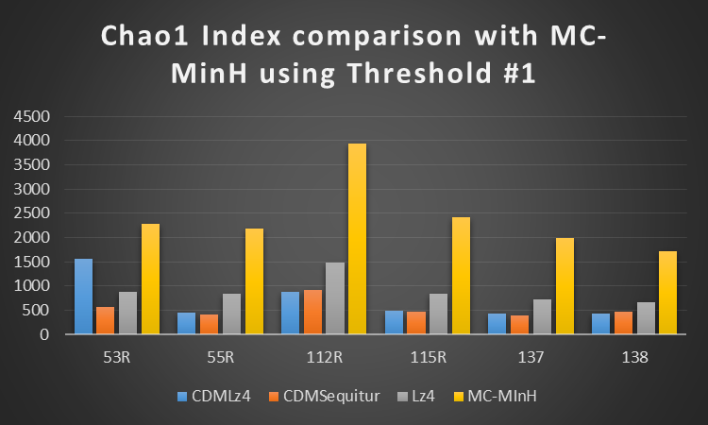

Figure 1

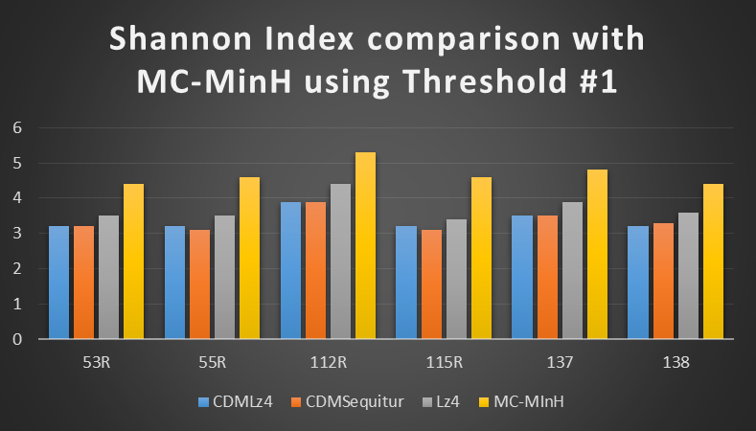

Figure 2

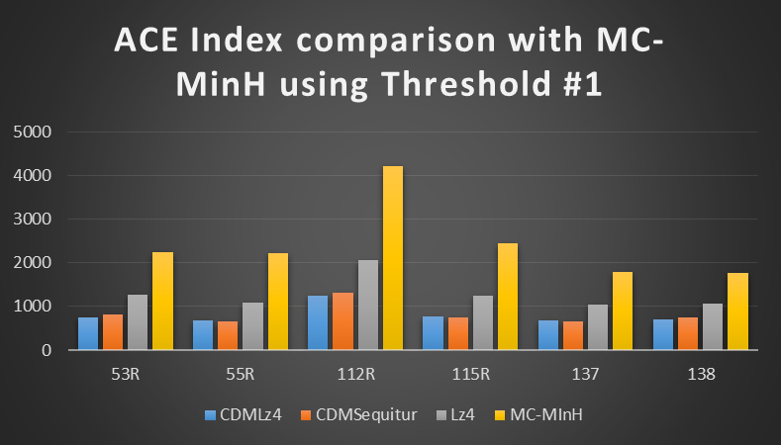

Figure 3

**Species Diversity comparison with MC-MinH using Threshold #2**

|  |  |  |  |  |
| --- | --- | --- | --- | --- |
| SID | Algorithm | Chao1 Index | Shannon Index | ACE Index |
| 53R | CDMLz4 | 1949.1 | 4.3 | 2140.1 |
| CDMSequitur | 1615.9 | 3.9 | 2147.8 |
| Lz4 | 1951.1 | 4.1 | 2424.1 |
| MC-MInH | 2276.3 | 4.4 | 2243.7 |
| 55R | CDMLz4 | 1766.1 | 4.4 | 2304.4 |
| CDMSequitur | 1499.3 | 4.1 | 1945.7 |
| Lz4 | 1619.6 | 4.1 | 2096.7 |
| MC-MInH | 2182.8 | 4.6 | 2214.1 |
| 112R | CDMLz4 | 3304.4 | 5.1 | 4479.5 |
| CDMSequitur | 2755.1 | 4.9 | 3942.1 |
| Lz4 | 3060.4 | 5.1 | 4296.9 |
| MC-MInH | 3931.3 | 5.3 | 4202.7 |
| 115R | CDMLz4 | 2087.3 | 4.3 | 2822.3 |
| CDMSequitur | 1908.4 | 4.0 | 2356.8 |
| Lz4 | 1999.9 | 4.1 | 2449.6 |
| MC-MInH | 2411.4 | 4.6 | 2455.8 |
| 137 | CDMLz4 | 1583.0 | 4.6 | 2054.3 |
| CDMSequitur | 1763.0 | 4.5 | 2024.1 |
| Lz4 | 1344.3 | 4.4 | 1813.2 |
| MC-MInH | 1992.2 | 4.8 | 1800.1 |
| 138 | CDMLz4 | 1557.2 | 4.2 | 2159.1 |
| CDMSequitur | 1354.4 | 4.0 | 1888.2 |
| Lz4 | 1305.1 | 4.1 | 1942.8 |
| MC-MInH | 1713.8 | 4.4 | 1760.3 |

Table 4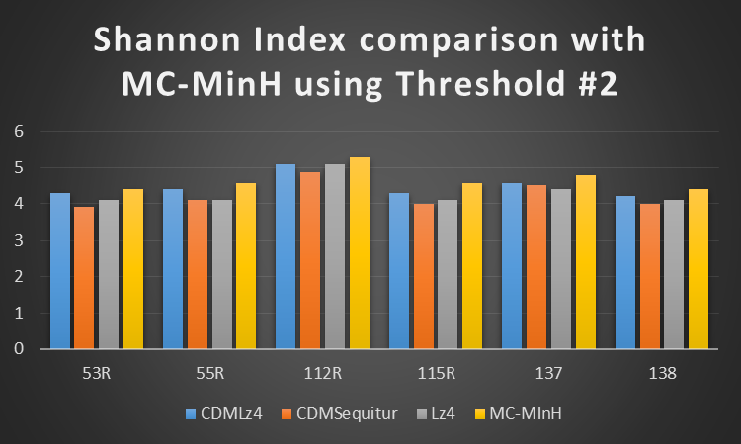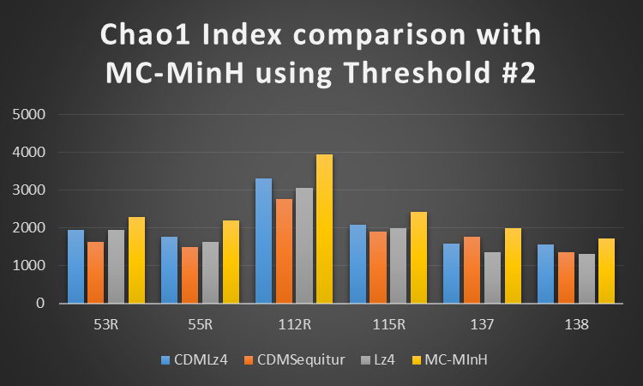

Figure 4

Figure 5

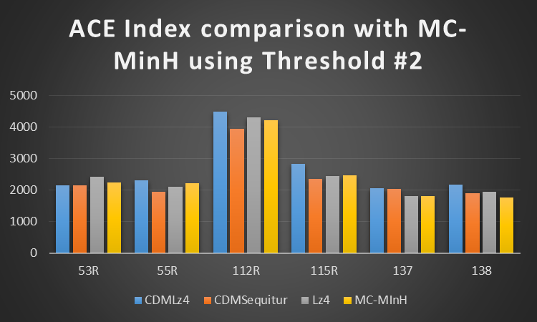

Figure 6

# Discussion

The results show a definite increase in the diversity of the clusters with the thresholds chosen by number of clusters versus weighted similarity. CDMLz4 has the fastest runtime indicating it is the most efficient of the algorithms. It outperforms all of the algorithms except MC-MinH in terms of speed. In terms of accuracy, it has a much higher weighted similarity compared to MC-MinH, and comparable species diversity statistics. Weighted similarity is calculated based on how similar the sequences within a cluster are; however CDMLz4 and MC-MinH both use slightly different similarity metrics so the W. Sim comparison is not precise. Differences of 2-3% aren’t indicative of major accuracy differences, especially because the two algorithms have very similar diversity metrics.

Although CDMSequitur and Lz4 are comparable to CDMLz4 in terms of accuracy metrics, the run time of those two algorithms are much greater, ranking them in the 5th-8th place range for most of the data sets. Therefore of the three algorithms, CDMLz4 is the most practical for future use.